ASSIGNMENT-4

Date:04/09/2024

Reg no:2022503045

1. Write a java program to perform string methods by considering the given string inputs.

Code:

public class Practice_3045 {  
 static String *s1*="Welcome to Java";  
 static String *s2*=*s1*;  
 static String *s3*=new String("Welcome to Java");  
 static String *s4*=*s1*.intern();  
 public boolean equal(String s1,String s2){  
 return s1==s2;  
 }  
  
 public static void main(String[] args){  
 Practice_3045 obj =new Practice_3045();  
 System.*out*.println("Sivaranjani -2022503045");  
 System.*out*.println("The string s1 is = "+*s1*);  
 System.*out*.println("s1==s2 "+obj.equal(*s1*,*s2*));  
 System.*out*.println("s2==s3 "+obj.equal(*s2*,*s3*));  
 System.*out*.println("s1.equalsIgnoreCase(s2) "+*s1*.equalsIgnoreCase(*s2*));  
 System.*out*.println("s2.equals(s3) "+*s2*.equals(*s3*));  
 System.*out*.println("s2 == s4 "+*s2* == *s4*);  
 System.*out*.println("s1 + s2 "+*s1* + *s2*);  
 System.*out*.println("s1.charAt(0) "+*s1*.charAt(0));  
 System.*out*.println("s1.indexOf('j') "+*s1*.indexOf('j'));  
 System.*out*.println("s1.indexOf(\"to\") "+*s1*.indexOf("to"));  
 System.*out*.println("s1.lastIndexOf('a') "+*s1*.lastIndexOf('a'));  
 System.*out*.println("s1.lastIndexOf(\"o\", 15) "+*s1*.lastIndexOf("o", 15));  
 System.*out*.println("s1.codePointCount(0, s1.length()) "+*s1*.codePointCount(0, *s1*.length()));  
 System.*out*.println("s1.length() "+*s1*.length());  
 System.*out*.println("s1.substring( 3) "+*s1*.substring( 3));  
 System.*out*.println("s1.substring(1, 3) "+*s1*.substring(1, 3));  
 System.*out*.println("s1.startsWith(\"Wel\") "+*s1*.startsWith("Wel"));  
 System.*out*.println("s1.endsWith(\"Java\") "+*s1*.endsWith("Java"));  
 System.*out*.println("s1.toLowerCase() "+*s1*.toLowerCase());  
 System.*out*.println("s1.toUpperCase() "+*s1*.toUpperCase());  
 System.*out*.println("“ Hi”.trim() "+" Hi".trim());  
 System.*out*.println("s1.replace('o', 'O') "+*s1*.replace('o', 'O'));  
 System.*out*.println("s1.replaceAll(\"o\", \"O\") "+*s1*.replaceAll("o", "O"));  
 System.*out*.println("s1.replaceFirst(\"o\", \"O\") "+*s1*.replaceFirst("o", "O"));  
 *s1*=*s1*.replaceAll("o","O");  
 String[] res=*s1*.split("O");  
 System.*out*.println("s1.split(\"O\") --- >");  
 for(String str:res)  
 System.*out*.print(str+" ");  
 System.*out*.println();  
 res=*s1*.split("O", 4);  
 System.*out*.println("s1.split(\"O\",4) --- >");  
 for(String str:res)  
 System.*out*.print(str+" ");  
 System.*out*.println();  
 char[] string= *s1*.toCharArray();  
 System.*out*.println("s1.toCharArray()--->");  
 for(char c:string)  
 System.*out*.print(c+" ");  
 System.*out*.println();  
 System.*out*.println("s1.codePointAt(0) "+*s1*.codePointAt(0));  
 System.*out*.println("s1.contains(\"or\") "+*s1*.contains("or"));  
 System.*out*.println("String.join(\"-\", s1, s2, s3) "+String.*join*("-", *s1*, *s2*, *s3*));  
  
  
 }  
}

output:

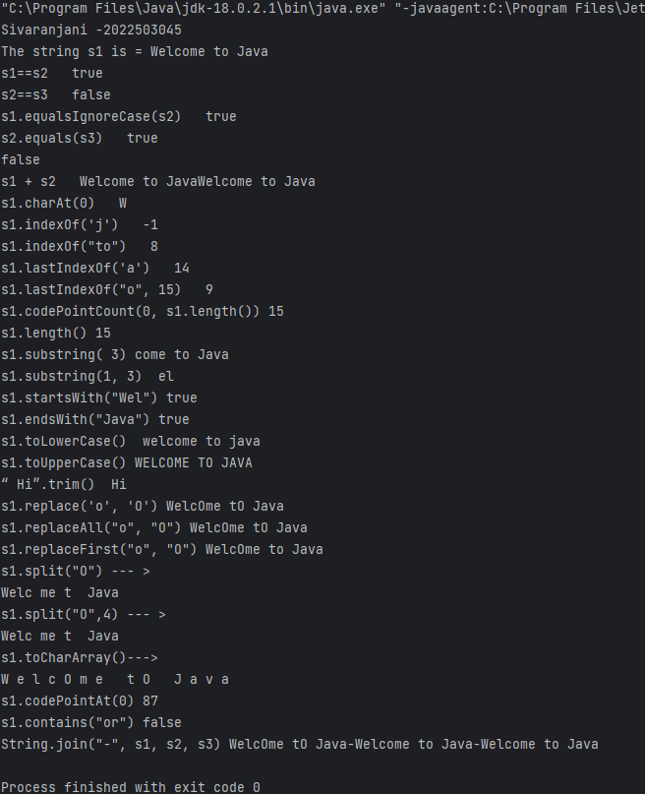

2. Write a java program to read the string and displays the reverse of the string.

CODE:

import java.util.Scanner;  
  
public class reverse_3045 {  
 public static void main(String[] args){  
 System.*out*.println("Sivaranjani -2022503045");  
 Scanner sc=new Scanner(System.*in*);  
 System.*out*.println("Enter a String :");  
 String str=sc.next();  
 StringBuilder sb=new StringBuilder(str);  
 int start=0;  
 int end=str.length()-1;  
 while(start<end){  
 char temp=sb.charAt(start);  
 sb.setCharAt(start,sb.charAt(end));  
 sb.setCharAt(end,temp);  
 start++;  
 end--;  
 }  
 System.*out*.println("The reversed string is "+sb.toString());  
 }  
}

output:

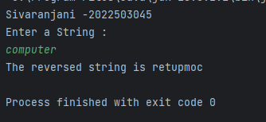

3. Write a java program to count the number of occurrence of the each letter in the given string using single array

code:

import java.util.Scanner;  
  
public class occurance_3045 {  
 public static void main(String[] main){  
 Scanner sc=new Scanner(System.*in*);  
 int[] alphabets=new int[26];  
 System.*out*.println("enter the string :");  
 String str=sc.nextLine();  
 str=str.toLowerCase();  
 for(int i=0;i<str.length();i++){  
 if(str.charAt(i)!=' ')  
 alphabets[str.charAt(i)-'a']++;  
 }  
 for(int i=0;i<26;i++){  
 if(alphabets[i]!=0){  
 System.*out*.println((char)(i+'a')+"-->"+alphabets[i]);  
 }  
 }  
 }  
}

output:

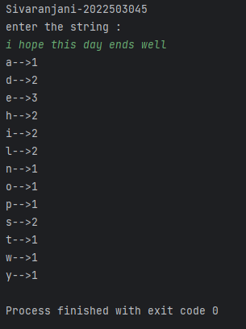

4. Write a java program that extracts all numbers from a given string and returns them as a new string.For example, "a1b2c3" should return "123"

code:

import java.util.Scanner;  
  
public class stringExtract_3045 {  
 public String extractNumber(String str){  
 StringBuilder sb=new StringBuilder();  
 for(int i=0;i<str.length();i++){  
 if(str.charAt(i)>='0' && str.charAt(i)<='9'){  
 sb.append(str.charAt(i));  
 }  
 }  
 return sb.isEmpty()?"": sb.toString();  
 }  
 public static void main(String[] args){  
 Scanner sc=new Scanner(System.*in*);  
 System.*out*.println("Enter a string :");  
 String str=sc.nextLine();  
 stringExtract_3045 obj=new stringExtract_3045();  
 String res=obj.extractNumber(str);  
 if(!res.isEmpty())  
 System.*out*.println("The extracted number string is : "+res);  
 else  
 System.*out*.println("There is no numbers in the string");  
 }  
}

output:

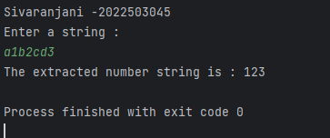

5. Write a Java program that performs string compression using the counts of repeated characters.

code:

import java.util.Scanner;  
  
public class compression_3045 {  
 public String compressed(String str) {  
 StringBuilder sb = new StringBuilder();  
 int count = 1;  
 char temp = str.charAt(0);  
 for (int i = 1; i < str.length(); i++) {  
 if (str.charAt(i) != temp) {  
 sb.append(temp);  
 sb.append(count);  
 temp = str.charAt(i);  
 count = 1;  
 } else {  
 count++;  
 }  
 }  
 sb.append(temp);  
 sb.append(count);  
 if(sb.length()<str.length())  
 return sb.toString();  
 return str;  
 }  
 public static void main(String[] args){  
 System.*out*.println("Sivaranjani -2022503045");  
 Scanner sc=new Scanner(System.*in*);  
 System.*out*.println("Enter the string : ");  
 String str=sc.nextLine();  
 compression_3045 obj=new compression_3045();  
 System.*out*.println("The compressed string is "+obj.compressed(str));  
 }  
}

output:

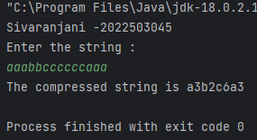

6. Write a java program to check the given string is Anagram or not

code:

import java.util.Scanner;  
  
public class anagram_3045 {  
 public boolean isAnagram(String str1,String str2){  
 if(str1.length()!=str2.length()){  
 return false;  
 }  
 str1=str1.toLowerCase();  
 str2=str2.toLowerCase();  
 int[] count=new int[26];  
 for(int i=0;i<str1.length();i++){  
 if(str1.charAt(i)!=' ')  
 count[str1.charAt(i)-'a']++;  
 }  
 for(int i=0;i<str2.length();i++){  
 if(str2.charAt(i)!=' ')  
 count[str2.charAt(i)-'a']--;  
 }  
 for(int i=0;i<26;i++){  
 if(count[i]!=0)  
 return false;  
 }  
 return true;  
  
 }  
 public static void main(String[] args){  
 System.*out*.println("Sivaranjani -2022503045");  
 Scanner sc=new Scanner(System.*in*);  
 System.*out*.println("Enter the first string : ");  
 String str1=sc.nextLine();  
 System.*out*.println("Enter the second string : ");  
 String str2=sc.nextLine();  
 anagram_3045 obj=new anagram_3045();  
 if(obj.isAnagram(str1,str2))  
 System.*out*.println("It is Anagram");  
 else  
 System.*out*.println("Not a Anagram");  
  
 }  
}

output:

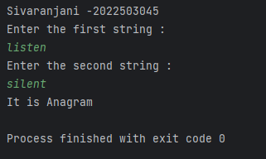

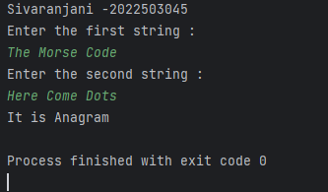

7Write a java program that read a two string of the given format and compares the string

Example:

15.10.10 is greater than 14.20.50 as 15 >14.

CODE:

import java.util.Scanner;  
  
public class productVersion_3045 {  
 public boolean greater(String s1,String s2){  
 String[] s1_form=s1.split("\\.");  
 String[] s2_form=s2.split("\\.");  
 int n= s1_form.length;  
  
 for(int i=0;i<n;i++){  
 if(Integer.*parseInt*(s1_form[i])>Integer.*parseInt*(s2_form[i]))  
 return true;  
  
 }  
 return false;  
 }  
 public static void main(String[] args){  
 System.*out*.println("Sivaranjani -2022503045");  
 Scanner sc=new Scanner(System.*in*);  
 System.*out*.println("Enter the first product version string : ");  
 String str1=sc.nextLine();  
 System.*out*.println("Enter the second product version string : ");  
 String str2=sc.nextLine();  
 productVersion_3045 obj=new productVersion_3045();  
 if(obj.greater(str1,str2))  
 System.*out*.println(str1+" is greater than "+str2);  
 else  
 System.*out*.println(str1+" is not greater than "+str2);  
 }  
  
  
}

OUTPUT:

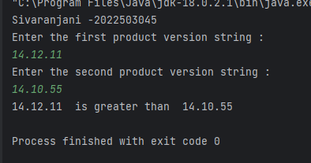

8. Write a java program to compare the email is valid is invalid and retruns the username and domain name

code:

import java.util.Scanner;

public class validEmail_3045 {

    public boolean isValid(String str){

        if(!str.contains("@"))

            return false;

        String[] after_amper=str.split("@");

        String username=after_amper[0];

        if(username.length()>25)

            return false;

        if(after_amper.length!=2)

             return false;

        for(int i=0;i<username.length();i++){

            char c=str.charAt(i);

            if(!(c>='a' && c<='z'||c>='A' && c<='Z'||c=='_'||c=='-'||c=='.'||c>='0' && c<='9'))

                return false;

        }

        String[] domain=after_amper[1].split("\\.");

        if(domain.length!=2)

             return false;

        System.out.println("Username:"+username);

        System.out.println("Domain: ."+domain[1]);

        return true;

    }

    public static void main(String[] args){

        Scanner sc=new Scanner(System.in);

        System.out.println("Sivaranjani -2022503045");

        System.out.println("Enter the mail:");

        String str=sc.nextLine();

        validEmail_3045 obj=new validEmail_3045();

        if(obj.isValid(str))

             System.out.println("It is a Valid mail");

        else

            System.out.println("Not a valid mail");

    }

}

OUTPUT:

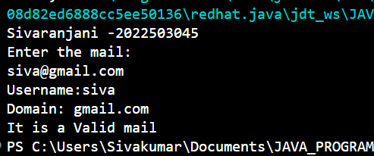

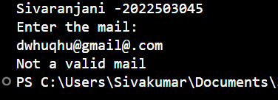

9. Write a java program to create a dictionary using 2D string array any 10 programming languages.Write a method that return the definition for the input of PL name.

Code:

import java.util.Scanner;  
  
public class languageDefine_3045 {  
 String[][] languages={  
 {"Java","pure object oriented programming language by James Gosling"},  
 {"Python","An easy-to-learn language that's relevant for real-world needs."},  
 {"C++","Object oriented programming language by Stroustrup"},  
 {"PHP","PHP stands for Hypertext Preprocessor, and it's an open-source programming language used for web development."},  
 {"SQL","SQL stands for Structured Query Language, and it was standardized in 1986 by the American National Standards Institute"},  
 {"R","heavily used in statistical analytics and machine learning applications."},  
 {"C","Dennis Ritchie and Brian Kernighan developed C in 1972 for programming computer operating systems."},  
 {"Perl","Perl is a powerful programming language with many features and applications"},  
 {"Ruby","Ruby is an open-source natural programming language that focuses on simplicity and productive use for back-end programming."},  
 {"Go","Robert Griesemer, Rob Pike, and Ken Thompson designed Go at Google, and it was launched in 2009."}  
 };  
 public void getDefinition(String pl){  
 boolean flag=false;  
 for(int i=0;i<10;i++){  
 if(pl.equalsIgnoreCase(languages[i][0])){  
 System.*out*.println(languages[i][0]+" : "+languages[i][1]);  
 flag=true;  
 break;  
 }  
 }  
 if(!flag){  
 System.*out*.println("mentioned programming language is not present");  
 }  
  
 }  
 public static void main(String[] args){  
 System.*out*.println("Sivaranjani -2022503045");  
 Scanner sc=new Scanner(System.*in*);  
 System.*out*.println("Enter the programming language:");  
 String str=sc.nextLine();  
 languageDefine_3045 obj=new languageDefine_3045();  
 obj.getDefinition(str);  
 }  
}

output:

